Project Planning Phase

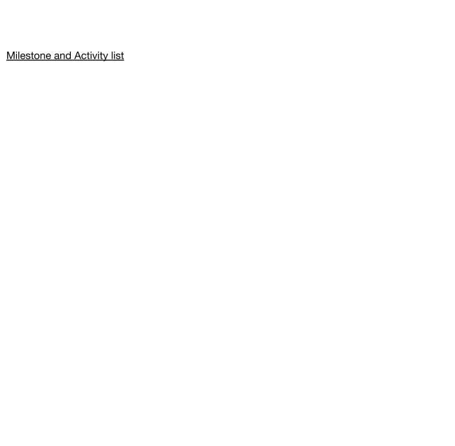Milestone and Activity list

|  |  |
| --- | --- |
| Date | 26 October 2022 |
| Team ID | PNT2022TMID17729 |
| Project Name | Personal Assistance for Seniors Who Are Self-Reliant |
| Marks | 4 Marks |

|  |  |  |  |  |  |  |
| --- | --- | --- | --- | --- | --- | --- |
| **Sprint** | **Functional Requirement (Epic)** | **User Story Number** | **User Story / Task** | **Story Points** | **Priority** | **Team Members** |
| Sprint-1 | Registration and Login | USN-1 | To create **Medicine Reminder Website. Such that** User can Register their details through the website | 20 | High | Sathish. S  Mohit. S |
|  |  |  |  |  |  |  |
| Sprint-2 | Cloud and database | USN-2 | To store Medicine details of the patients which allows us to give remainder for the patients to take tablets on time. | 20 | High | Sathish. S  Sasikumar. S |
| Sprint-3 | A Reminder through the TTS Service | USN-3 | The Pills Reminder app notifies or reminds the user when to take Specific medicine through the **Text-to-Speech (TTS) Service** | 20 | High | Sathish. S  Santhosh Kumar. R |
| Sprint-4 | Testing and Deployment to user | USN-4 | To make sure that this Software is handy to users. | 20 | High | Sathish. S |